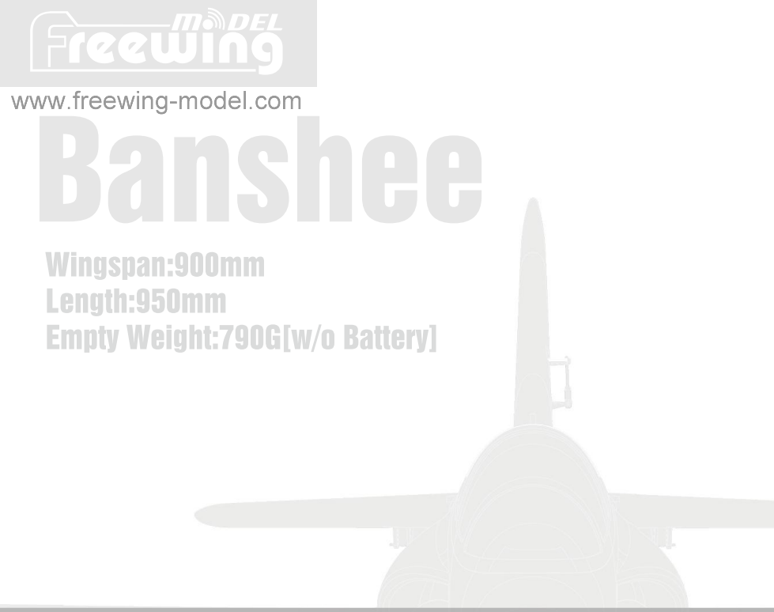

■电调使用说明：
- 本款产品使用了新的40AV2版电调,新增“降落后油门反推 ■车”功能.
- 此电调有二条连接线,分别为：油门(Throttle)信号控制线 剛门反跡!I车(Reverse Brake )控制线.
明：
•油门信号控制线(Throttle )
插入接收机油门通道，控制油门大小.
-油门刹车(Reverse Brake )控制■
插入接收机任意空闲二^通道,飞机唾着地后，在遥控器上, 通过切换此对应通道开关，开启"油门反推刹■”功能.
，告：
- 油门朝刹车(Reverse Brake )控制线必须插入接收机进行连接, ,则，电调将不会启动.
- 聖询离瞄,宓宓程中,不能开启"油门车”功能, 否则会丧失动力，导致严重飞行事故.
庄 ESC Instruction :
1 .This product uses the new 40AV2 ESC, and adds the
"Reverse throttle deceleration after landing" function.
- This ESC has two connecting cables: "Throttle" signal control cable and "Reverse Brake" control cable.
- Connection Instruction
-"Throttle" signal control cable insert into the throttle channel of receiver to control the throttle size.
-"Reverse Brake" control cable insert into any free two-way switch channel of receiver. After the plane lands on the ground, switch the corresponding channel switch on the radio to turn on the "Reverse throttle deceleration" function.
Note:
- " Re verse Brake" control cable must insert into the receiver for connection, otherwise the ESC will not start.
- After the model aircraft is off the ground, during the flight, the "throttle reverse thrust" function cannot turn on,otherwise the forward power will be lost,
and resulting in a serious flight accident.

EN 1~10

中 11-20 Eng

Catalog
Introduction
Product basic information
Package list
PNP Assembly instructions
Install main wing
Install vertical stabilizer
Install verticaL horizontal stabilizer
Install nose landing gear
Install rear landing gear
Install battery
Pushrod instructions
Important additional notes
Center of gravity
PNP Parameter setting
Control direction test
Dual rates
Pre-installed component overview Servo direction
Motor specification
产品规格参数 包装列表
PNP组装步骤介绍 主翼组装 垂尾组装 垂尾、平尾组装 前机轮组装 后机轮组装 电池介绍 舵面控制钢丝尺寸及安装孔位 重要附加说明 重心示意图
PNP调试介绍 模型舵面测试 舵量范围
预装电子配件介绍 舵机介绍 电机介绍

Freewing Banshee introduction ei
Thank you for purchasing the Freewing 64mm EDF jet Banshee. It is made of high-density EPO material. Before the product leaves the factory, the spraying and decals steps have been completed, and the degree of completion is high. This product also provides two versions of PNP and ARF Plus for selection.
Freewing "Banshee" electric jet is a new 64mm ducted aircraft built again after the Stinger 64 was launched for 12 years. In terms of appearance, the light and flat nose is perfectly combined with the streamlined body, making it stylish and concise. The fluorescent green theme color, with black and white mottled gradient style honeycomb pattern and gray lines, has a unique visual impact, which not only shows the personality, but also effectively enhances the recognition during the flight. In terms of structure, this product adopts a modular structure design, and the assembly of major components is completed through plastic structural parts and screws, which is easy to maintain and update accessories.
Through the summary of the use of previous products and the accumulation of design experience, the Wingspan of the Banshee is set as the captain respectively: 900mm / 950mm. Compared with the conventional 64-ducted products, the size has been increased to improve the flight quality of the product. The main wing adopts a leading edge sawtooth design layout, which further enhances the lateral stability of the product at low speed and elevation attitude. In the process of research and development, repeated testing of various parameters, as well as multiple optimizations and modifications, made the Banshee meet the performance that a basic sports machine should have. The PNP version of Banshee is pre-installed with a 4S 14.8V 64mm12-blade out-runner power system, which is full of power and has an average speed of 152KPH (95MPH). During the take-off, the directional stability is good, and the roll distance is about 20 meters. During the flight, the action responds quickly, and the operation process is soft and linear.
Under the same conditions, during the horizontal turn, the altitude loss is small. In the case of mastering the essentials of relevant flying movements, Banshee can easily complete common easy and difficult movements including "'side flying'¹. The fixed landing gear made of <D3mm diameter carbon steel is simple and durable. During the landing process, the landing gear has an appropriate degree of softness and hardness. With a little practice and adaptation, the bouncing phenomenon during the landing process can be reduced or even avoided, and the landing gear can smoothly land and glide.
Maneuverability, controllability and stability are the striking features of this brand new Banshee electric model aircraft. It is very suitable to use this cost-effective product to practice related flight actions. I hope you like it!(Note: When using 6S 22.2V 64mm 12-blade out-runner power system, the average speed is 175KPH (109MPH). You can consult and purchase this upgraded power pack through our official or official designated channels)
/j\ NOTE： This is not a toy. Notforchildren under 14 years. Young people underthe age of 14 should only be permitted to operate this model underthe instruction and supervision of an adult. Please keep these instructions for further reference after completing model assembly.

Note:
1 .This is not a toy! Operater should have a certain experience, beginners should operate under the guidance of professional players.
- Before install, please read through the instructions carefully and operate strictly under instructions.
- Cause of wrong operation,Freewing and its vendors will not be held responsible for any losses.
- Model planes' players must be on the age of 14 years old.
- This plane used the EPO material with surface spray paint, don¹1 use chemical to clean, otherwise it will damage.
- You should be careful to avoid flying in areas such as public places,high-voltage-intensive areas,near the highway, near the airport or any other place where laws and regulation clearly prohibit
- You cannot fly in bad weather conditions such as thunderstorms.snows....
- Model plane's battery, don't allowed to put in everywhere. Storage must ensure that there is no inflammable and explosive materials in the round of 2M range.
- Damaged or scrap battery should be properly recycled, it can't discard to avoid spontaneous combustion and fire.
10.ln flying field, the waste after flying should be property handledjt can't be abandoned or burned.
11.In any case, you must ensure that the throttle is in the low position and transmitter switch on, then it can connect the lipo-battery in aircraft.
12.Do not try to take planes by hand when flying or slow landing process. You must wait for landing stop, then carry it.
Freewing 64mm Banshee EDF Jet
m^DEL ®
I ^recuiing
Item No.：FJ112
Ver.FU112.01 www.freewing-model.com

Product Basic information

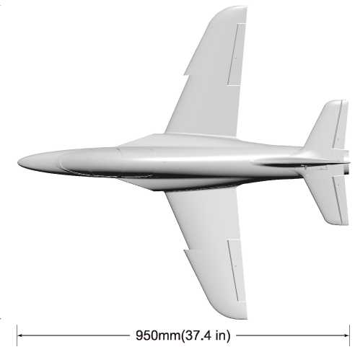
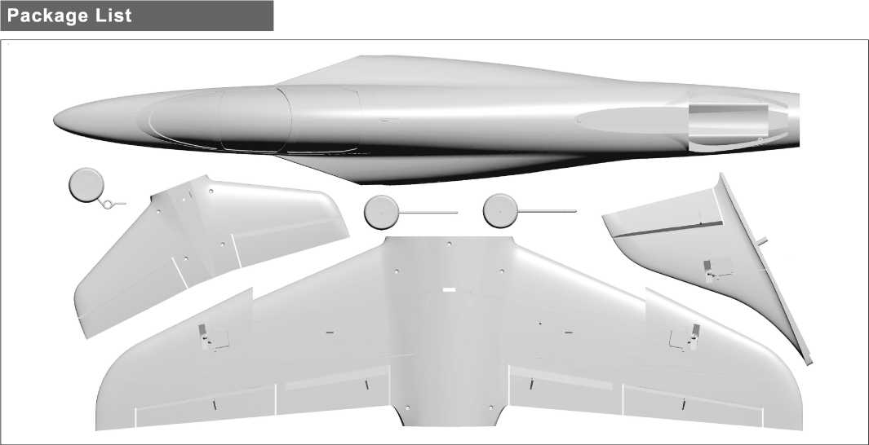
Note： The parameters in
here are derived from test result using our accessories.
(•u 一寸.gcoEE006
Standard Version
If use other accessories, the test result will be different. Any problem since of using other accessories, we are not able to provide technical support.
Different equipment include different spareparts. Please refer to the following contents to check your sparepart list.
Wingload: 91.8 g/dm²
Wing Area: 11 dm²
Motor: 2840-2850KV O/R Motor
Servo: 9g Digital plastic servo x8
ESC: 40A Brushless(Thrust Reverse function) Ducted fan: 64mm 12-blade fan
Weight: 790g(w/o Battery)
Li-Po Battery:4S 2200-2600mAh
Landing gear:Fixed landing gear
No. |  | Name | PNP |  | ARF Plus
1 |  | Fuselage | Pre-installed all electronic parts |  | Pre-installed servo
2 |  | Main wing | Pre-installed all electronic parts |  | Pre-installed servo
3 |  | Horizontal tail | Pre-installed all electronic parts |  | Pre-installed servo
4 |  | Vertical tail | Pre-installed all electronic parts |  | Pre-installed servo
No. | Name |  |  | PNP |  | ARF Plus
5 | Wheel |  |  | V
6 | Pushrod |  |  | V |  | y/
7 | Manual |  |  | y/

www.freewing-model.com
1
Freewing 64mm Banshee EDF Jet
ltemNo.:FJ112
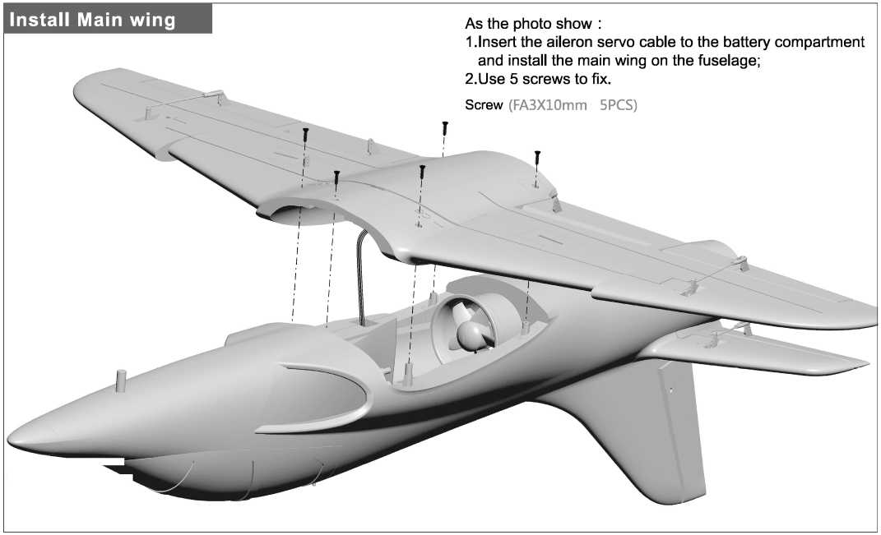

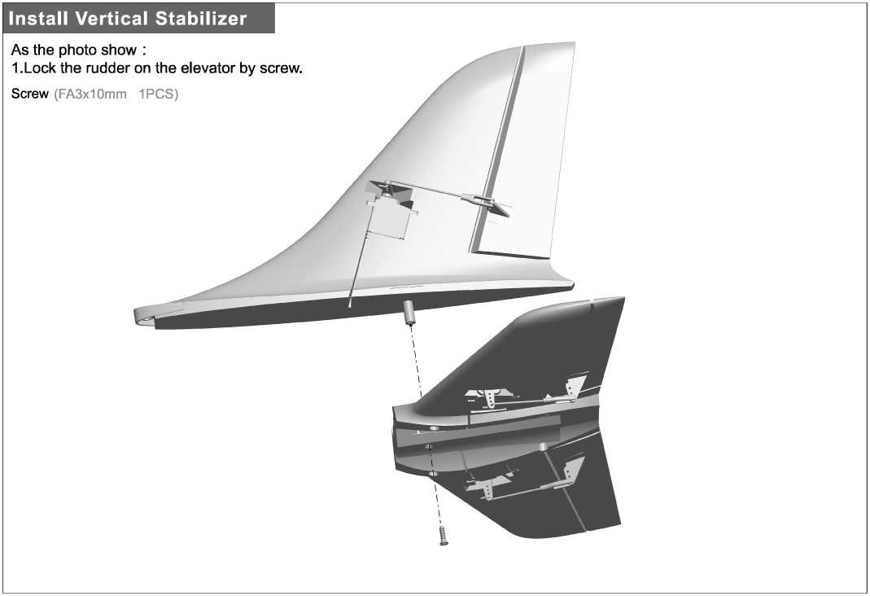
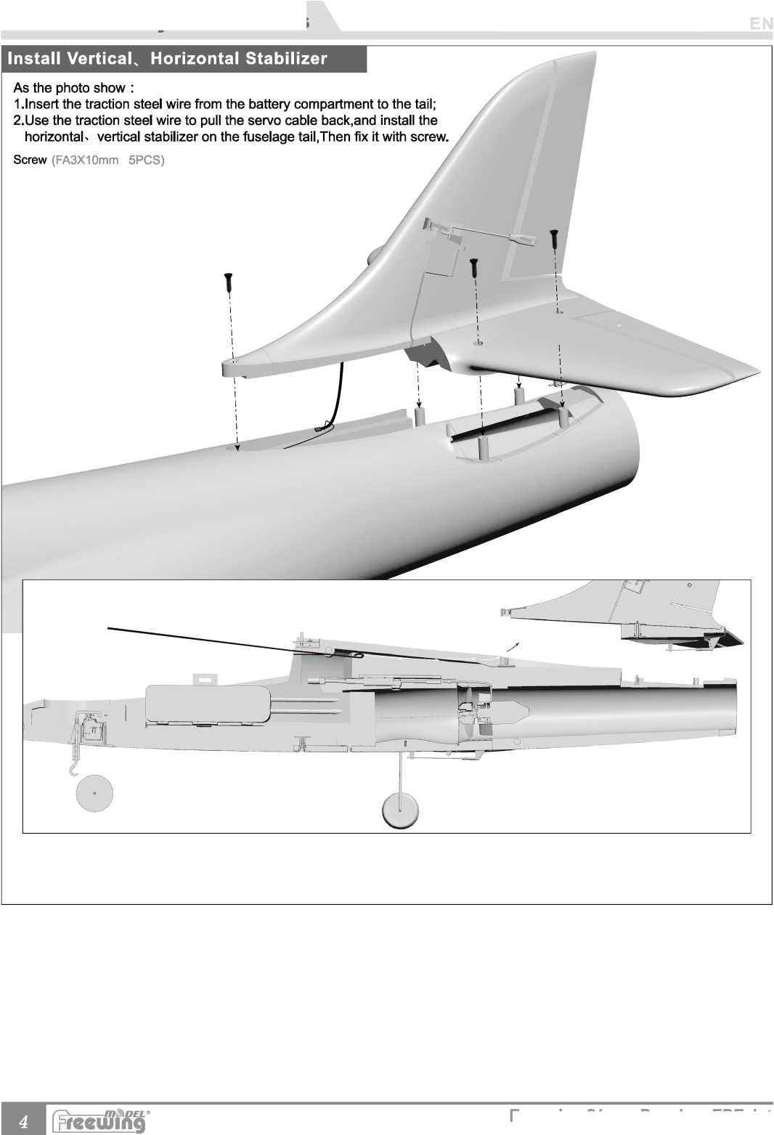
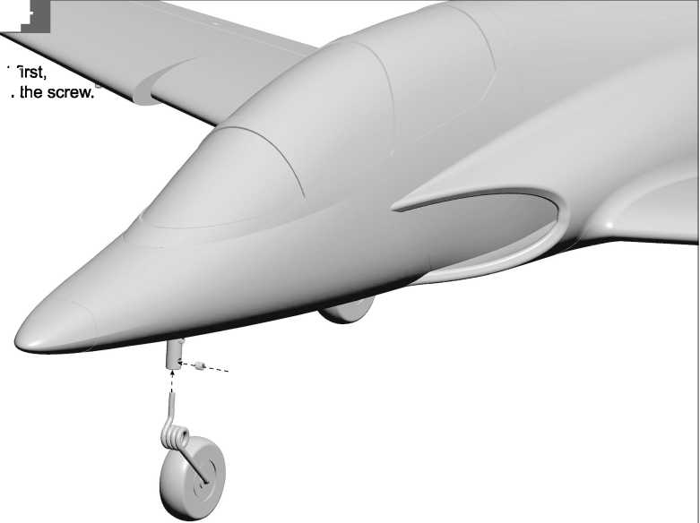
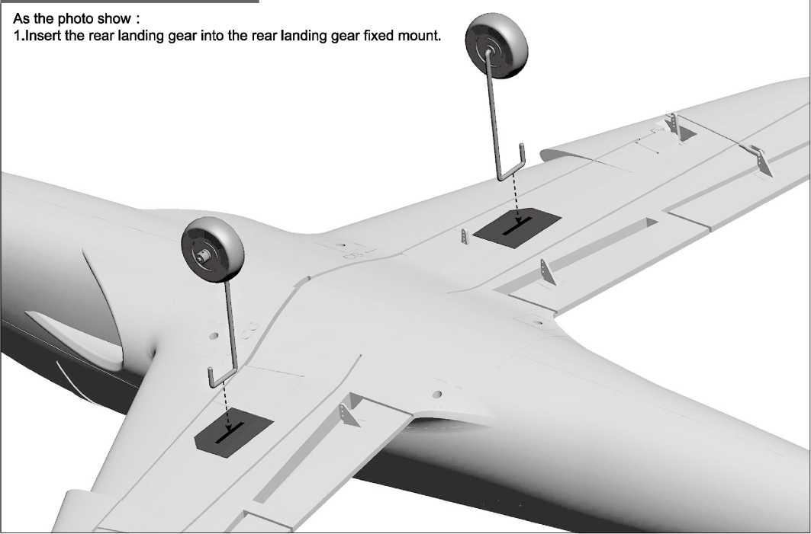
Install Nose Landing Gear
Screw (M4X4mm 1PCS)
As the photo show :
1.Insert the nose landing gear set fi and then fix the nose wheel with t

Install Rear Landing Gear

Freewing 64mm Banshee EOF Jet
[pfeeujinQ
Battery recommended location
Before connecting the battery and receiver, please switch on the transmitter power and make sure the throttle stick is in the lowest position. Bind your receiver to your transmitter according to your transmitter's instruction manual.
Battery size: 4S 220
Battery weight :226a
We recommend the following LiPo battery:
4S 14.8V 2200mAh~4S 14.8V 2600mAh
Discharge rate of C 2 35C

Pushrod instructions
Aileron pushrod length
Pushrod diameter 01.2mm
78mm
0")
Aileron push rod mounting hole
❸
4
Flap pushrod mounting hole(lnside)
Flap pushrod length
60mm
•史一3/8”“
Pushrod diameter 01.2mm

Elevator pushrod mounting hole
Elevator pushrod length
49mm
(1-15/16")
Pushrod diameter 01.2mm
Rudder pushrod length
Rudder pushrod mounting hole
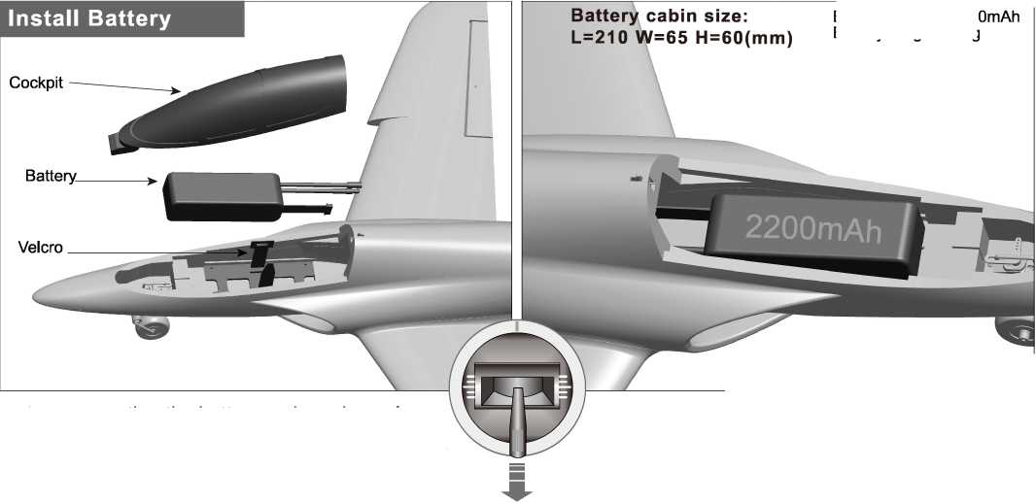
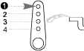
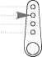
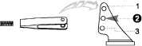

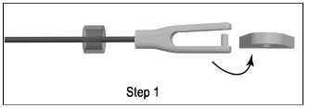
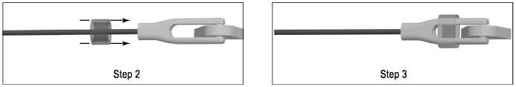
O

4

邮 Pushrod diameter 01.2mm
64mm
(2-1/2")

Important additional notes
The Y-type clevis used in this product is equipped with a transparent silicone ring for secondary reinforcement, which can effectively prevent the clevis from accidentally loosening.
As shown in the following figure, when you buckle the clevis into the control surface horn, use the silicone ring to cover the clevis.

Center of Gravity
Correct Center of Gravity (”CG”) is critical for enabling safe aircraft stability and responsive control. Please refer to the following CG diagram to adjust your aircraffs Center of Gravity.
-Depending on the capacity and weight of your choosen flight batteries, move the battery forward or backward
to adjust the Center of Gravity.
-If you cannot obtain the recommended CG by moving the battery to a suitable location, you can also install a counterweight to achieve correct CG. However, with the recommended battery size,
a counterweight is not required. We recommend flying
without unnecessary counterweight.
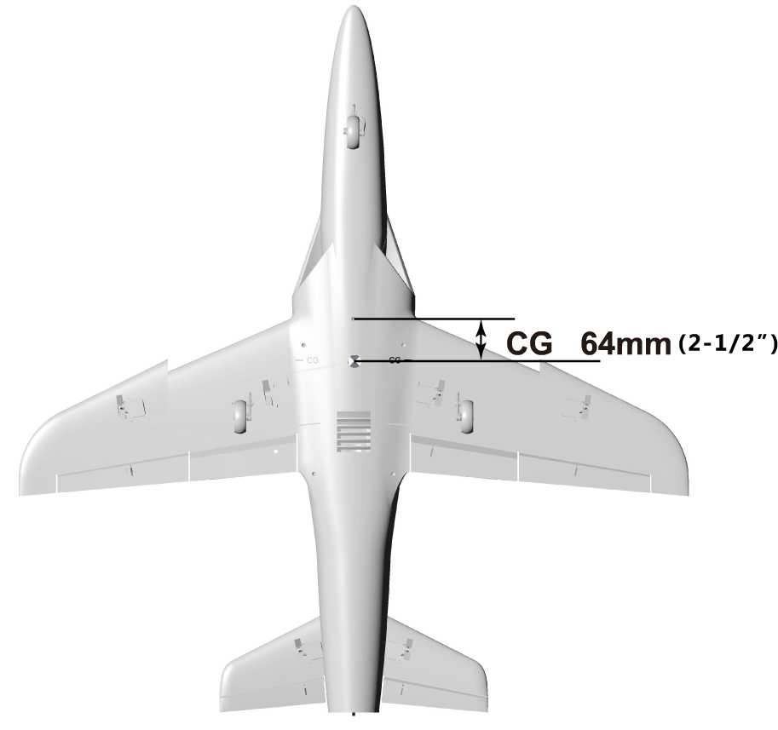

ESC Instruction
1 .This product uses the new 40A V2 ESC, and adds the"Reverse throttle deceleration after landing" function.
- This ESC has two connecting cables: "Throttle" signal control cable and "Reverse Brake" control cable.
- Connection Instruction
-"Throttle" signal control cable insert into the throttle channel of receiver to control the throttle size.
-"Reverse Brake" control cable insert into any free two-way switch channel of receiver. After the plane lands on the ground, switch the corresponding channel switch on the radio to turn on the "Reverse throttle deceleration" function.
Note:
1 ."Reverse Brake" control cable must insert into the receiver for connection, otherwise the ESC will not start.
2.After the model aircraft is off the ground, during the flight, the "throttle reverse thrust" function cannot turn on, otherwise the forward power will be lost, and resulting in a serious flight accident.

Control Direction Test
After installed the plane, before flying, we need a fully charged battery and connect to the ESC, then use radio to test and check that every control surface work properly.

Aileron
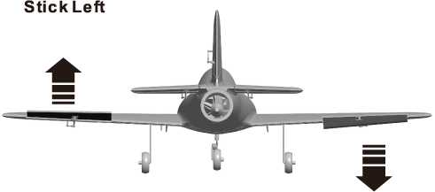
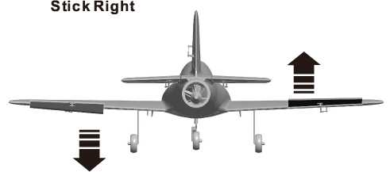
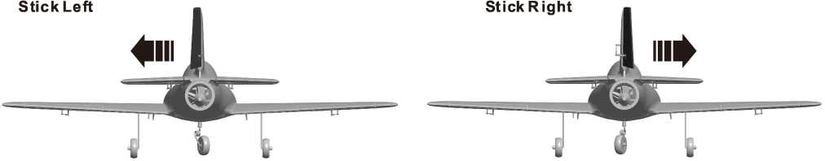

Elevator
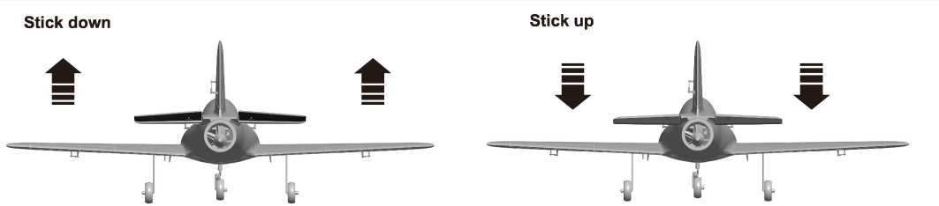
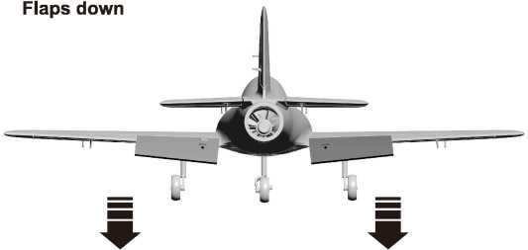

Dual Rates
According to our testing experience, use the following parameters to set Aileron/Elevator Rate. Program your preferred Exponential % in your radio transmitter. We recommend using High Rate for the first flight, and switching to Low Rate if you desire a lower sensitivity. On successive flights, adjust the Rates and Expo to suit your preference.
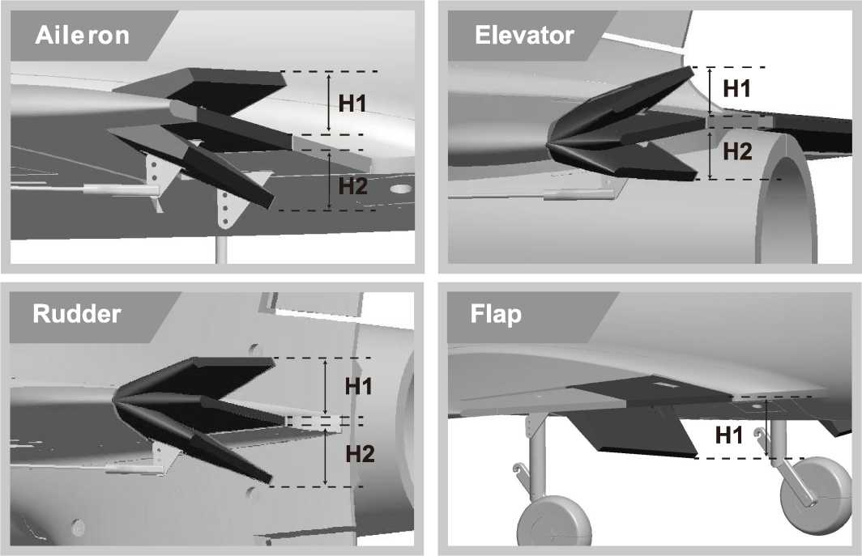

 | Aileron  (Measured closest to the fuselage) | Elevator  (Measured closest to the fuselage) | Rudder  (Measured from the bottom) | Flaps
Low Rate | H1/H2 9mm/9mm  D/R Rate : 60% | H1/H2 17mm/17mm  D/R Rate : 75% | H1/H2 24mm/24mm  D/R Rate : 80% | Hl 11mm
High Rate | H1/H2 12mm/12mm  D/R Rate : 80% | H1/H2 23mm/23mm  D/R Rate : 100% | H1/H2 31mm/31mm  D/R Rate : 100% | Hl 24mm

Item No.：FJ1l2
Ver.FJ112.01

Pre-Installed Component Overview
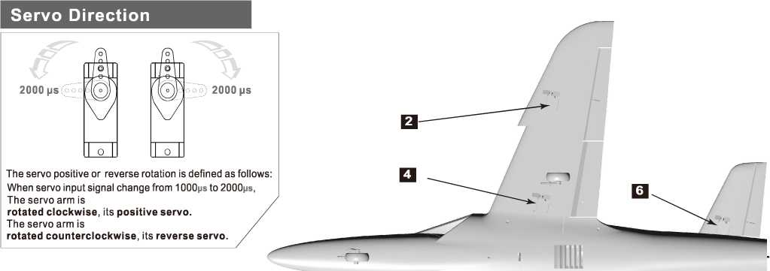
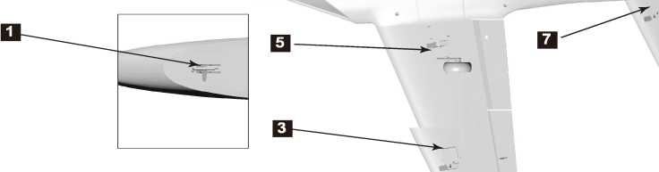

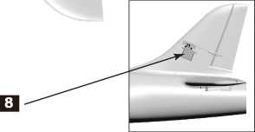
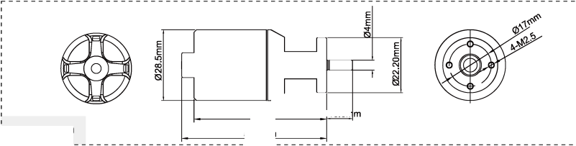
Position | Servo regulation | No. | Pos. / Rev. | Cable length
Nose gear steering servo | 9g plastic servo | 1 | Reverse | 300mm
Aileron(L) | 9g plastic servo | 2 | Positive | 400mm
Aileron(R) | 9g plastic servo | 3 | Positive | 400mm
Flap(L) | 9g plastic servo | 4 | Positive | 200mm
Flap(R) | 9g plastic servo | 5 | Reverse | 200mm
Elevator(L) | 9g plastic servo | 6 | Positive | 600mm
Elevator(R) | 9g plastic servo | 7 | Reverse | 600mm
Rudder | 9g plastic servo | 8 | Positive | 600mm

J
10.5rr
■ 2840-2850
If you need to purchase another brand's servo, please refer to the following list to choose a suitable servo.

Motor Specification
\ 2840-2850KV brushless motor
i use 4S 14.8V lipo battery and
；40AESC.
\ Note: If you need other
■ motor to use, please refer to
\ the dimension shown on the
| left to select your motor, to
\ make sure that the motor you
¹ purchased can install
53.5mm
\ successfully.
Model | KV Value | Volate  (V) | Current  (A) | Pull  (g) | RPM | Weight  (g) | No Load Current | Propeller | ESC
2840-2850KV | 2850RPM/V | 14.8 | 40 | 1350 | 42180 | 145 | 2.7A | 64mm Ducted Fan | 40A
58.5mm

10
I Fireeujing
Freewing 64mm Banshee EDF Jet

中文版
感谢您购买Freewing 64mm Banshee "女妖"电动涵道模型飞机。它采用高密度EPO材料制作，产品出厂前, 均已完成喷涂及贴础骤，完成度较高。本产品同时提供了 PNP和ARF Plus （空舵）二个版本，以供湧。
飞冀"女妖”电动涵道模型飞机融Stinger 64上市十二年之后,再次全新打造的一款64mm涵道级练习飞机。 夕卜观方面,轻扁平化的机头，与流线型机身,完美结合,显得时尚、简练。荧光绿主题色,搭配黑白颜色的斑驳渐变 风格蜂巢圏案及灰色线条，有着独特地视觉冲击力,在彰显个性的同时,有效增强了飞行过程中的识§11度。结构方面, 本品采用模块化结构设计，通过塑料结构件及螺丝完成各大部件的拼装，易于后期维护及配件更新.
通过对以往产品的使用反馈总结,以及设计经验的积累。Banshee "女妖"的翼展机长分别设定为：900mm / 950mm,较常规64涵道綴!1的产品，尺寸有所增加,以改善产品的飞彳亍品质。切采用了前缘锯齿遍布局,『 步增强产品在低速、仰角姿态时的横向稳定性。在研发过程中，对各种参数的反复测试，及多次优化修改，使 Banshee "女妖"符合一款基础运动机应有的各项表现。PNP版本的Banshee "女妖"，预装4S 14.8V 64mm 12 叶夕隋动力组，动力充沛，平均时速152KPH（95MPH）。起飞滑跑时，方向稳定性较好，滑跑距离约20米。飞行过程中, 动作响应迅速,运作过程柔和、线性。在相同条件下,水平转弯过程中，高度损失较小.在掌握相关飞行动作要领 的情况下，Banshee "女妖"能够轻松完成包括"侧飞"在内的常见易、难动作。使用e3mm直径碳钢制作的固定 式起落架，简单耐用。瞄过程中北匕起牌软硬程度恰当，稍加练习适应挪可减少甚至避免瞄过程中的弹询觎象， 平稳落地滑行。
机动性、操控性、稳定性，三者均衡是这款全新Banshee "女妖”电动模型飞机的显著特点，使用这台极具性 价比的产品来练习相关飞行动作，非常合适，希望您喜欢!（备注：当使用6S 22.2V 64mm 12叶外转动力组时， 平均时速175KPHQ09MPH）。您可以通过我们官方或官方扌旨定渠道咨询和购买此升级动力组）。

重要提示
1模型飞机不是玩具，操作者需要具备一定的经验；没有经验的初学者，必须在有丰富经验的专业人士指引下，逐步学习!
- 在组装之前，必须认真阅读产品说明书严幟照说明书指示操作。
- 飞翼模型及其销售商,对于违反说明书的要求操作而造成的损失、】务不负任何法律责任!
4模型飞机的使用年龄必须是14岁以上的儿童或者成人。
产品使用EP。材料制成，表面喩由漆，不可随意使用化学制剂擦拭，否则会损唯型产品.
- 不可以在公共场合、高压线密集区、高速公路附近、机场附近或者其它法律法规明确禁止飞行的场合飞行。
- 不可以在雷雨、也大雪或者其它恶劣行。
- 模型飞机的电池产品,不可以随意乱扔,乱放。存放时，必须保证周边2 M范围内，无易燃、易爆物体。
- 损坏或者报废处理的模型飞机电池，应妥善回收处理，不准随意抛弃，避免自燃而引发火灾。
10在飞场飞行时,应做到妥善处理飞行后所产生的垃圾,不可随意抛弃、焚毁模型及其配件。
- 在任何情况下，都必须保证油门杆处于起始位、发射m处于打开状态时,才能连接模型飞机内部的动力电池.
- 无论是模型飞机是在正常飞行过程中，或者是在缓慢朧过程中，都不要尝试用手去回收模型•必须等模型廳停 稳以后，再进行回收！
A 注意:模型产品是具■垂;险性的产品,请禁止14岁以下的丿瞳玩耍,14岁以上的丿瞳,请在有飞行经验的成源导下使用,无飞行经验的购买者,应当在具有 电动涵道飞机飞密验的成人指导下使用!组装模型前,请仔细阅读说明书,按照说明书的要求进行安装.进行调试和飞行时，请職说明书指示的参数进行调整.
Freewing 64mm Banshee EDF Jet
c m^DEL ®
I Firceujinci
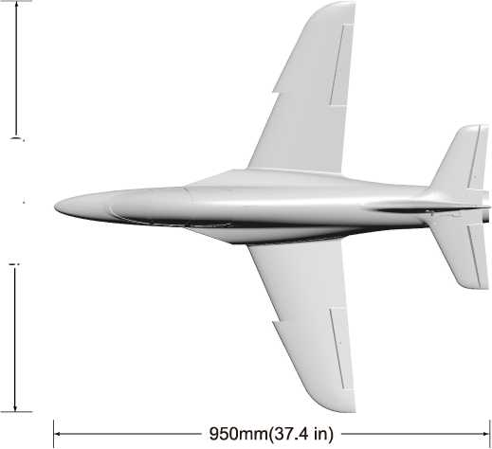
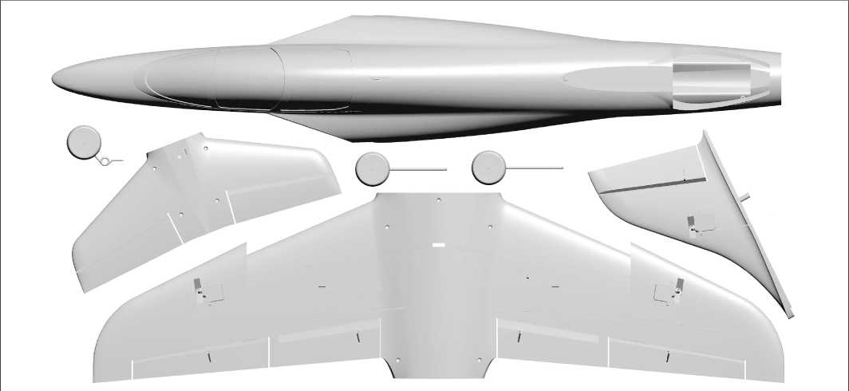
标准版
A 注意：此处各项绑（,均使用本公司配件测试得出,如果使用副厂配件，会有所差异。使用 配件时所产生的问题,我们将无法给予技术支持！
(•u 一寸
翼载荷：91.8 g/dm² 翼面积：11 dm² 舵机：9g塑料齿舵机x8 电机：2840-2850KV外转电机 涵道风扇：64mm 12叶塑料涵道 电调：40A无刷电调（带反推刹车功能） 起飞重量：790g（不含电池） 电池范围：4S 2200-2600mAh 起落架：固定式起落架

产品包装清单

打开产品包装，核对包装清单。 （不同配置的版本，包含内容不同！）
序号 | 配件名称 | PNP | ARFPIus |  | 序号 | 配件名称 | PNP | ARFPIus
1 | 机身 | 预装所有电子设备 | 预装舵机 |  | 5 | 机轮
2 | 主翼 | 预装所有电子设备 | 预装舵机 |  | 6 | 舵面控制钢丝 | A
3 | 平尾 | 预装所有电子设备 | 预装舵机 |  | 7 | 说明书 | A
4 | 垂尾 | 预装所有电子设备 | 预装舵机

Ver.FJ112.01
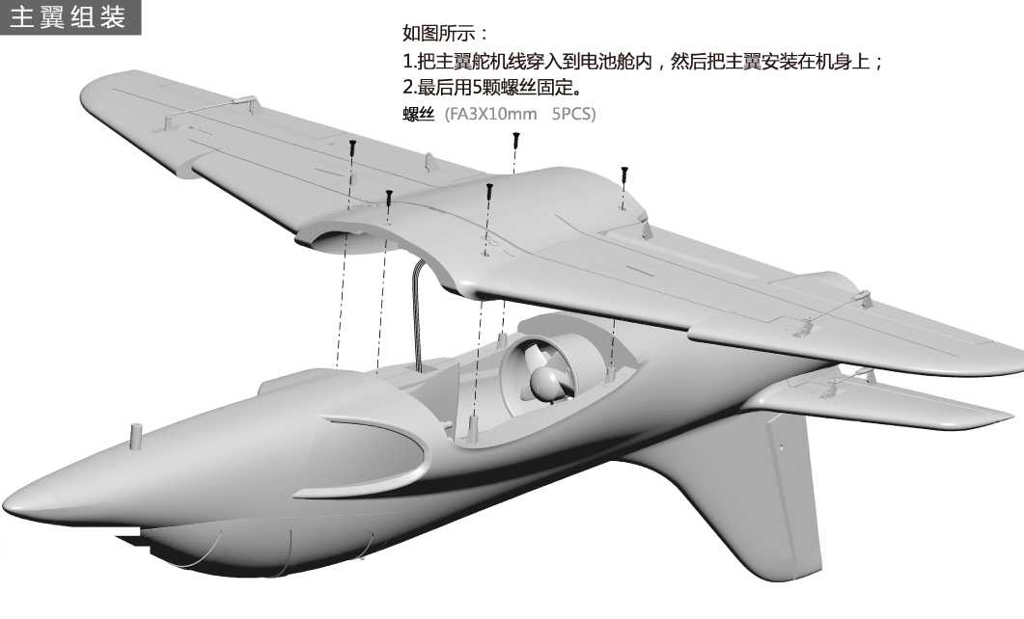
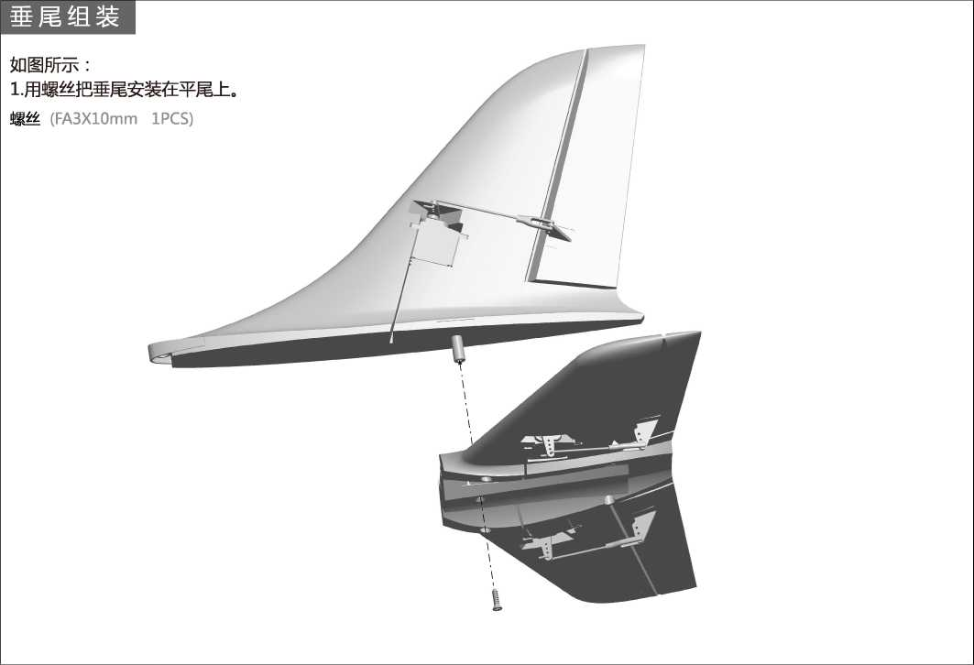
Freewing 64mm Banshee EDF Jet
c m^DEL ®
I pirecujing
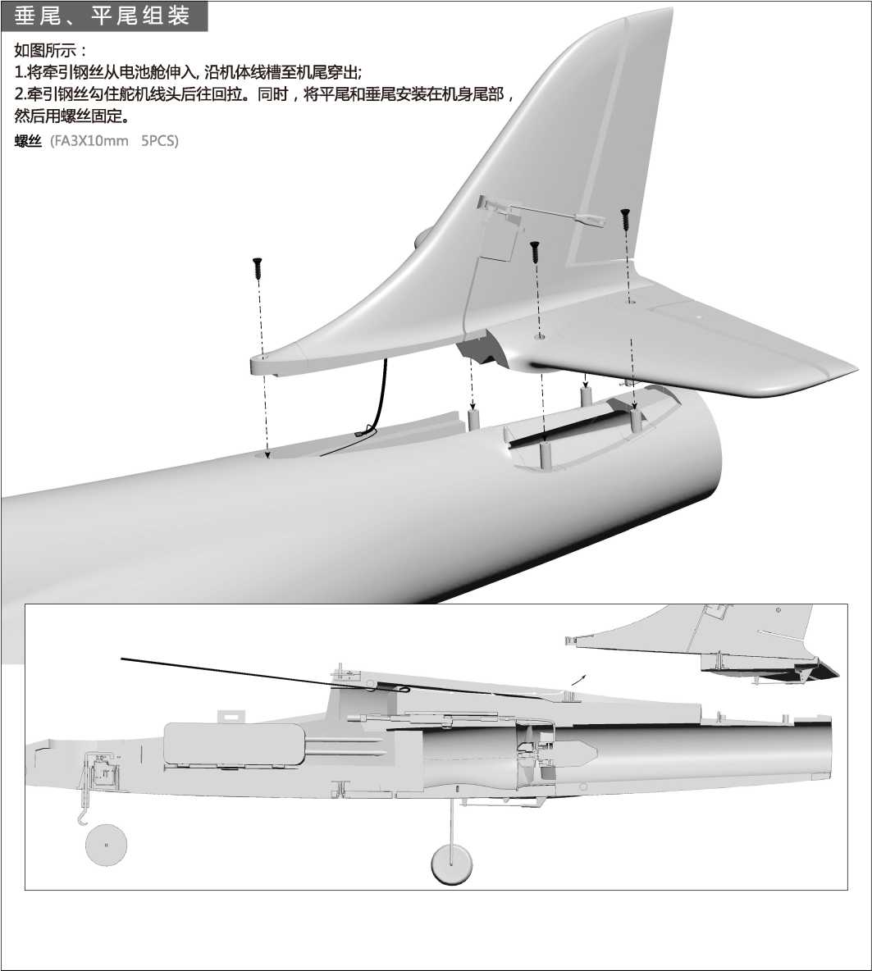
15
Freewing 64mm Banshee EDF Jet

[pirccujinQ
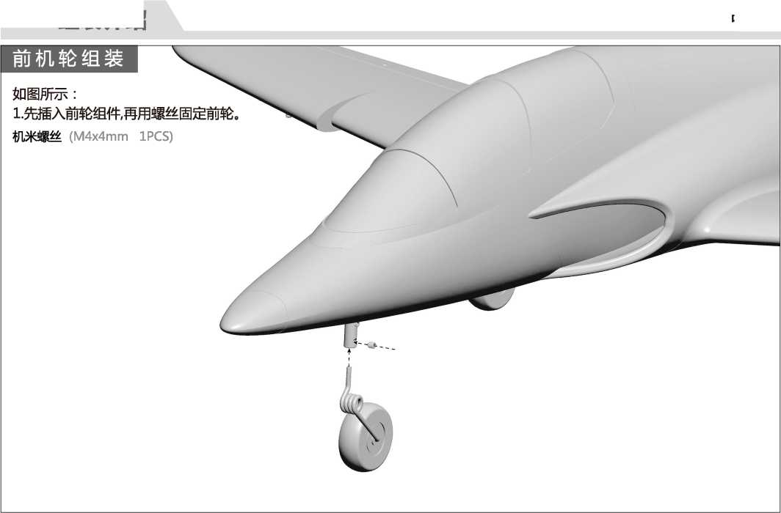
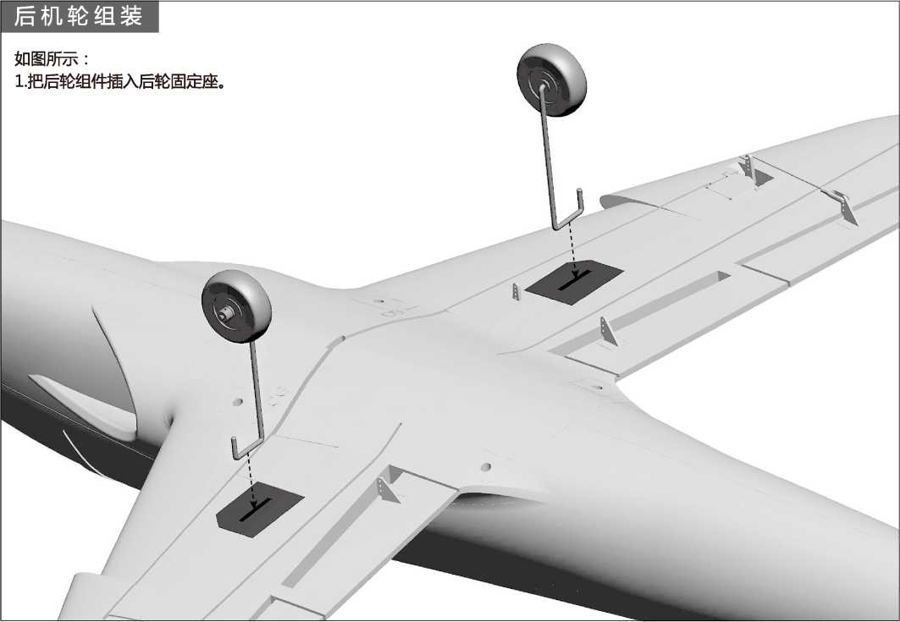

将电池与电调连接前,首先请打开发射机电源,确 认油门杆处于低位。
安装电池后，启动油门前,请保证没有任何物体在 螺旋桨转动直径以内,以免造成事故和人身伤害！
我们建议使用的电池容量和放电倍率如下：
4S 14.8V 2200mAh~4S 14.8V 2600mAh (1pcs) 放电倍率Z 35C
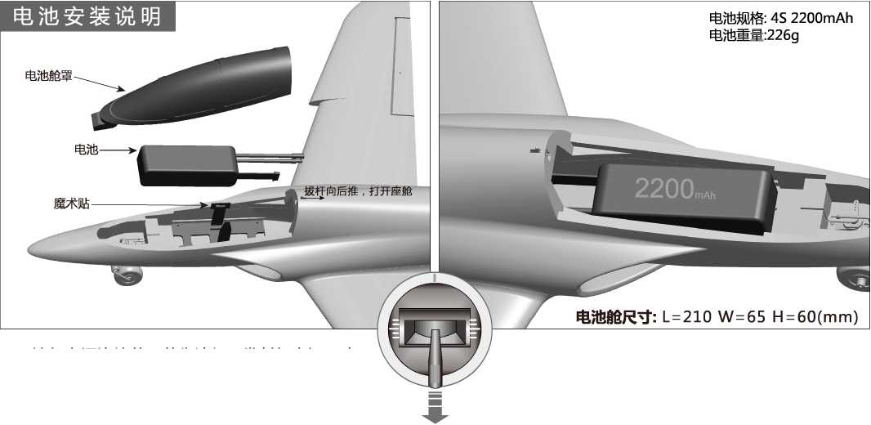

舵面控制钢丝尺寸及安装孔位

副翼控制钢丝尺寸
副翼控制钢丝安装孔位
78mm
(3")
册 钢丝直径01.2mm
襟翼控制钢丝安装孔位
襟翼控制钢丝尺寸
60mm
(2-3/8")
钢丝直径01.2mm
平尾控制钢丝安装孔位
平尾控制钢丝尺寸
49mm
(1-15/16")
钢丝直径01.2mm
❷
3
4
垂尾控制钢丝尺寸
垂尾控制钢丝安装孔位
64mm
(2-1/2^{w})
梱钢丝直径01.2mm
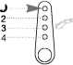
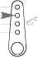
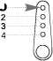
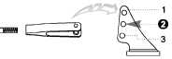

重要附加说明:
本产品所使用的"丫〃型夹头，均配备了透明硅胶圈进行二次加固，能有效防止夹头意外松开。 如下图所示，当您将夹头扣入舵面摇臂后，请使用硅胶圈套住夹头。
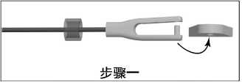
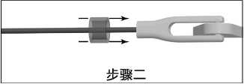
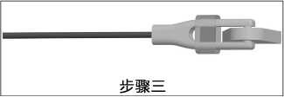

重心示意图
正确的重心，直接关系到飞行的成功与否，请参考下面的重心标示图，来调整飞机的重心。
-您可以将电池向前，或者向后移动,来调整飞机的重心；
-如果通过电池的移动无法调整到正确的重心位置,您还可以适当
的使用一些其它材料来配重，使飞机的重心处于正确的位置！
如图所示，在机腹表面已经雕刻了重心位置标记.
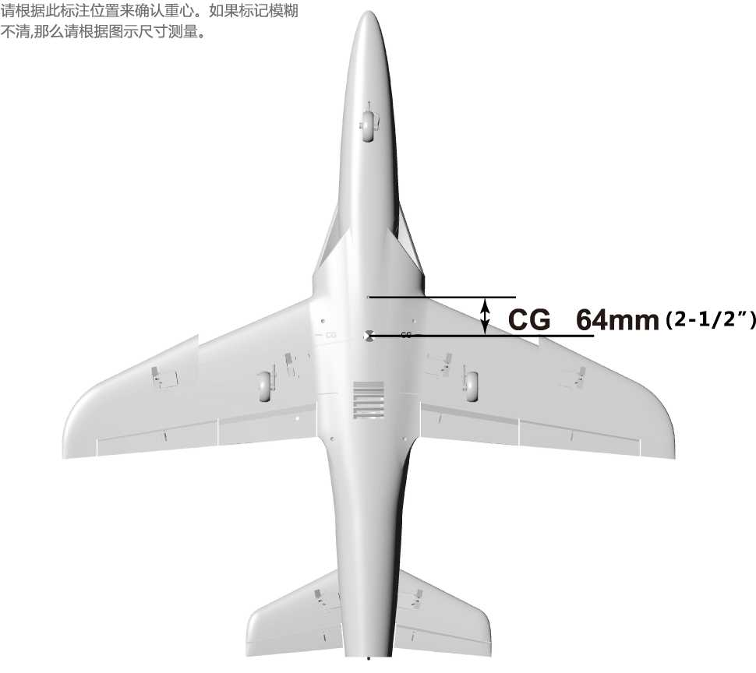

电调使用说明
L本款产品使用了新的40AV2版电调，新增"降落后油门反推刹车”功能。
- 此电调有二条连接线,分别为：油门(Throttle )信号控制线及油门反推刹车(Reverse Brake )控制线。
- 连接说明：
-油门信号控制线(Throttle)
插入接收机油门通道,控制油门大小。
-油门反推刹车(Reverse Brake )控制线
插入接收机任意空闲二程开关通道。飞机降落着地后,在遥控器上,通过切换此对应通道开关，开启"油门反推刹车"功能。 警告：
L油门反推刹车(Reverse Brake )控制线必须插入接收机进行连接,否则，电调将不会启动。
2.模型飞机离地后，在飞行过程中，不能开启"油门反推刹车"功能，否则会丧失动力，导致严重飞行事故。

舵面测试
当您按前面的步骤组装好飞机后，连接电池，用遥控器测试每个舵面的工作情况，检查各个 舵面是否处于居中位置，是否正常工作！

升降舵
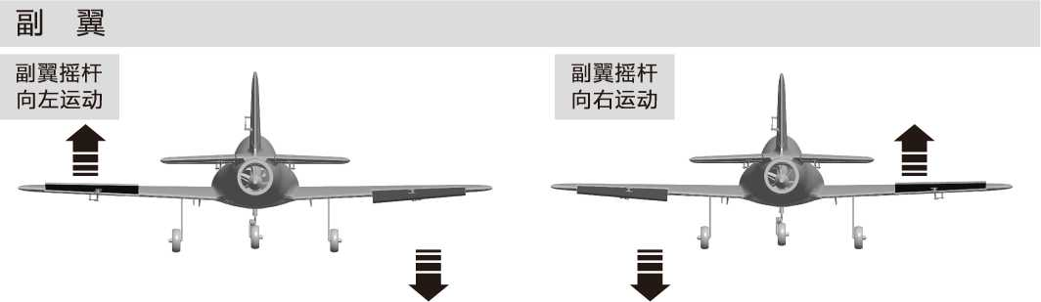
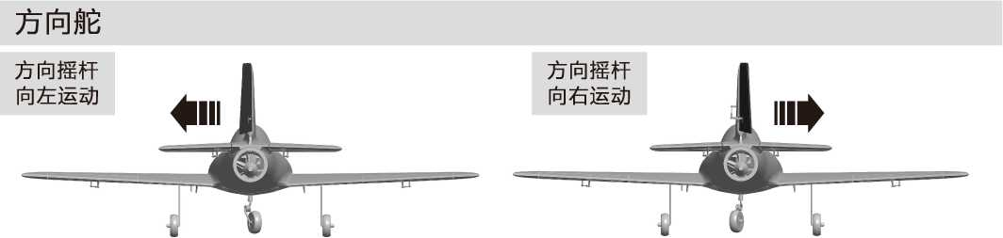
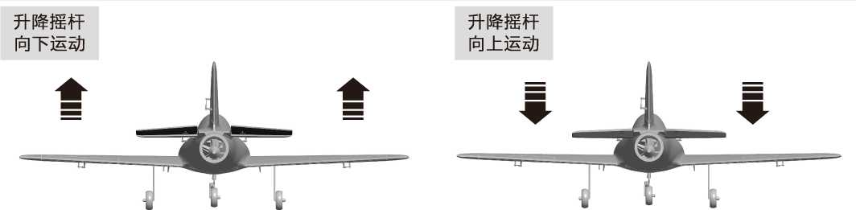
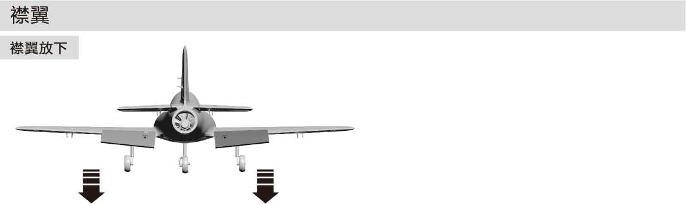

大、小舵参数
根据我们的测试经验,我们认为，按以下参数来设置大小舵量，将有助于飞行，舵量越大，模型飞机 的动作响应更快，动作幅度可以更大。我们建议初次飞行使用大舵量起飞,然后根据个人情况调整到适合 您的舵量。
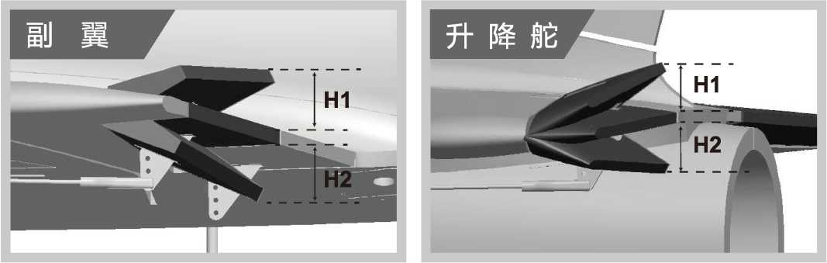
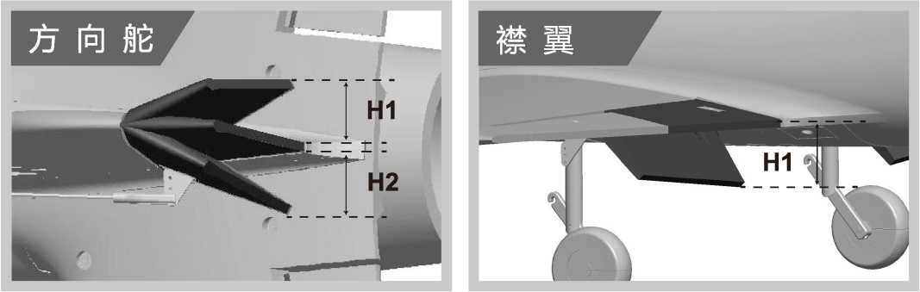

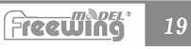
 | 副翼（内侧） | 升降舵（内侧） | 方向舵（下端） | 襟翼
小舵量 | H1/H2 9mm/9mm  舵量比率：60% | H1/H2 17mm/17mm 舵量比率：75% | H1/H2 24mm/24mm 舵量比率：80% | Hl 11mm
大花量 | H1/H2 12mm/12mm 舵量比率:80% | H1/H2 23mm/23mm 舵量比率:100% | H1/H2 31mm/31mm 舵量比率：100% | Hl 24mm

Freewing 64mm Banshee EDF Jet
Item No.：FU112
Ver.FU112.01
舵机位置 | 舵机规格 | 序号 | 方向性 | 线长
前轮转向 | 9g塑料 | 1 | 反向 | 300mm
副翼（左） | 9g塑料 | 2 | 正向 | 400mm
副翼（右） | 9g塑料 | 3 | 正向 | 400mm
襟翼（左） | 9g塑料 | 4 | 正向 | 200mm
襟翼（右） | 9g塑料 | 5 | 反向 | 200mm
平尾（左） | 9g塑料 | 6 | 正向 | 600mm
平尾（右） | 9g塑料 | 7 | 反向 | 600mm
垂尾 | 9g塑料 | 8 | 正向 | 600mm

如果您需要选购其它品牌的舵机进行安装, 请参考下面的表格选择的舵机
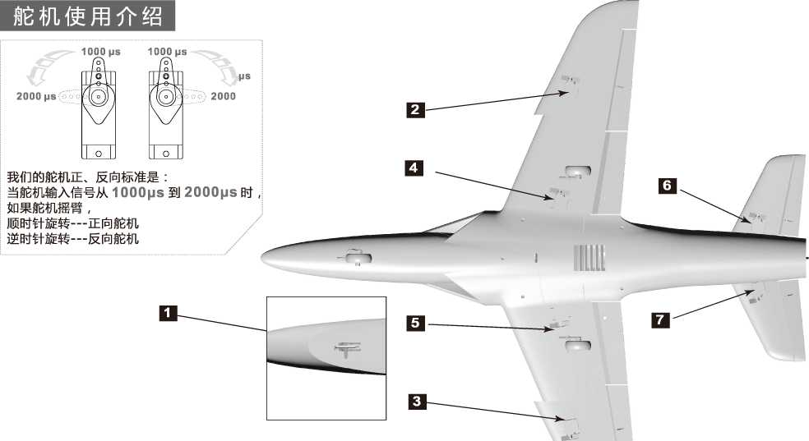
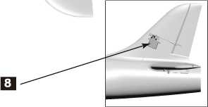

电机参数
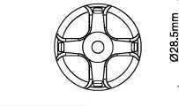
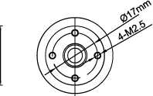
EEA
:2840-2850KV无刷马达，使用
:4S 14.8V的电池和40A电调。
:A注意：如果需要购买副厂马达
-使用，请参考左图所示的尺寸图，
¹来选择马达，确保您所购买的马达
:能够顺利安装。
10.5rrm
Model | KV Value | Volate  (V) | Current  (A) | Pull  (g) | RPM | Weight  (g) | No Load Current | Propeller | ESC
2840-2850KV | 2850RPM/V | 14.8 | 40 | 1350 | 42180 | 145 | 2.7A | 64mm Ducted Fan | 40A
58.5mm
:2840-2850

Freewing 64mm Banshee EDF Jet
C m^DEL ®
I Freeojing
ltemNo.:FU112

